**Face expression recognition**

**#Abstract:**

Recognizing facial emotions using the camera.

We made an import for the libraries to be used in our project, and then we displayed a group of pictures of feelings in the form of a chart, and then we counted the number of pictures to know the number of pictures in each of the 7 groups (emotions), we noticed that there is a group that contains few pictures, so we made more From the training and verification data for this group, then we fitted the model with the training and validation data, and after we made our own model, we saved the model and knew its accuracy, accuracy of drawing, loss and some other information.

It quickly and almost accurately sets the facial expressions (angry/disgust/fear/happy/neutral/sad/surprise) captured by the camera.

**#1. Introduction:**

* [**What is Artificial Intelligence (AI)?**](https://www.bing.com/ck/a?!&&p=2b4ff93ec95338c42e7a36ad444bb6232d853039fc6075bd96889cd75e816e97JmltdHM9MTY1MzU4NDgzNCZpZ3VpZD02M2Q4MTg3YS01NTRmLTQ4MDAtYjM5Ni1kNzE3NGQxMjNhZDEmaW5zaWQ9NTE0Mw&ptn=3&fclid=4a1208ba-dd16-11ec-8e7d-892c12a6187f&u=a1aHR0cHM6Ly93d3cuaWJtLmNvbS9jbG91ZC9sZWFybi93aGF0LWlzLWFydGlmaWNpYWwtaW50ZWxsaWdlbmNl&ntb=1)

Artificial intelligence leverages computers and machines to mimic the problem-solving and decision-making capabilities of the human mind.

**The following are the examples of AI-Artificial Intelligence:**

* Google Maps and Ride-Hailing Applications.
* Face Detection and recognition.
* Text Editors and Autocorrect.
* Chatbots.
* Computer vision
* Etc…
* **Goals of the Project**

The goals of this project are to establish a model that can classify 7 basic emotions: happy, sad, surprised, angry, disgust, neutral, and fear

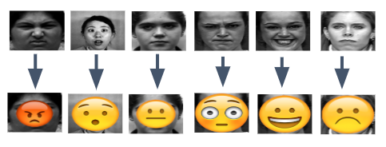

**Figure 1**

* **The General Problem**

In real life, people express their emotion on their face to show their psychological activities and attitudes in the interaction with other people. The primary focus of this project is to determine which emotion an input image that contains one facial emotion belongs to. Because human face is complex to interpret, emotion recognition can be speciﬁcally divided into classiﬁcation of basic emotion and classiﬁcation of compound emotion. For the goals of our project, the essential problem is to focus on the classiﬁcation of 7 basic emotions (shown at below):

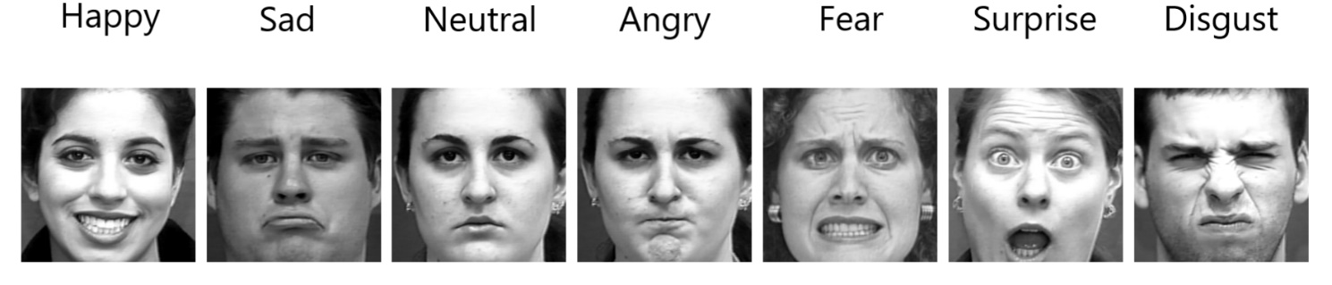

**Figure 2**

In this **document** we will talk about:

What is computer vision in particular and why do we use it, and some examples of it?

**Computer vision:**

Computer vision is a field of artificial intelligence (AI) that enables computers and systems to derive meaningful information from digital images, videos and other visual inputs — and take actions or make recommendations based on that information

Computer vision systems include a set of AI techniques. The latter allows a computer to have a human-like vision that extracts information from the visual world. The systems usually consist of a photo or video camera. They also include specialized software that identifies and classifies objects.

Machine vision and vision systems are often used as synonyms. But those are different processes. Yet, the two join forces to perceive visual stimuli and amplify AI business strategies.

A machine vision system applies a camera to view an object. At the same time, CV algorithms further process the visual content. Unlike machine vision, AI vision can be a stand-alone technology.

**The following are the examples of Computer vision**

* Face Detection and recognition.
* Object detection
* Object tracking‏
* Content-based image retrieval ‏
* Etc…
* Beforeexplaining any information, I have an important question, what is the difference between computer vision and human vision??

|  |  |
| --- | --- |
| **computer vision** | **human vision** |
| Allows computer to sense their surroundings and identify things, similar to how human vision perceive things. | Humans perceive the things as they are and retain what they recognize, storing it deep in the brain until they come across those things again. |
| Uses machine learning techniques and algorithms to identify, distinguish and classify objects. | Human vision is about how eyes detect light patterns and coordinate with the brain to translate light into images. |
| Object recognition is one of the most challenging problems in vision. | Humans recognize objects effortlessly, and have no problems describing objects in a scene. |

* This is an illustration of the principle of work of both computer vision and human vision

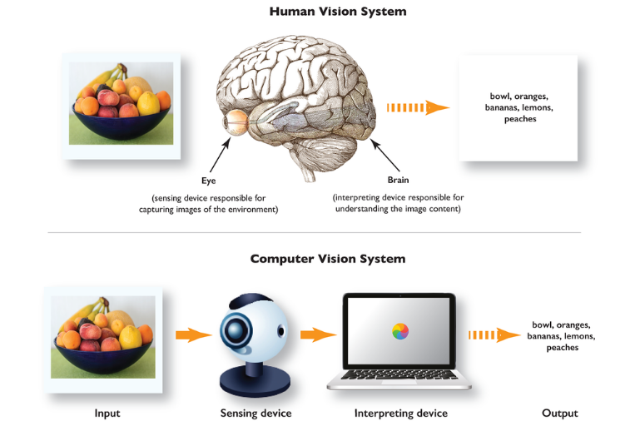

Now we will talk about **image classification using computer vision** with a simple explanation of its types with examples.

**Image Classification: -**

**Image Classification: -**

It’s the process of extracting information from the images and labelling or categorizing the images.

**There are two types of classification: -**

1. **Binary classification: -**

In this type of classification our output is in binary value either 0 or 1.

ex: happy or not happy

1. **Multi-class classification: -**

In this type of classification our output will be multi-class,

ex: sad or happy or surprised and so on…

* **example Image Classification using** **Computer vision**:

1. **Self-driving cars**
2. **Pedestrian detection**
3. **X-Ray analysis**
4. **CT and MRI**
5. **Face expression recognition**

**#2. Methodology:**

**How Face expression recognition works: -**

Recognizing facial emotions usually consists of four steps.

1. The first is to detect a face in an image and draw a rectangle around it
2. and the next step is to discover the features in this face area.
3. The third step is to extract spatio-temporal features from the components of the face.
4. The final step is to use a feature extraction classifier and output the recognition results with the extracted features.

**Figure 3** shows the facial emotion recognition procedure for an input image where the facial area and facial features are detected.

The contours of the face are visually prominent points such as the end of the nose, the ends of the eyebrows, and the mouth as shown in **(Figure 4)**.

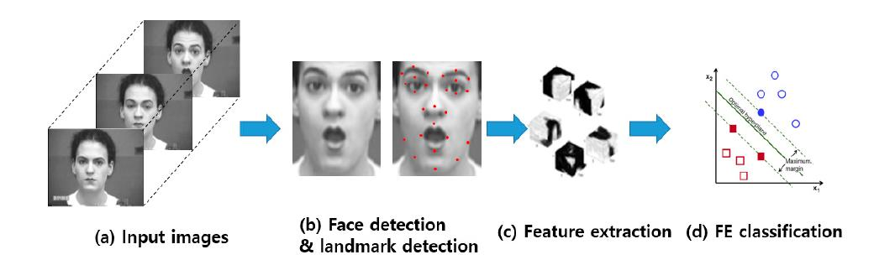

**Figure 3**

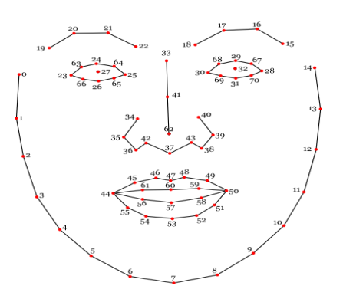

**Figure 4**

**What do I want to do??**

We have fetched the dataset for our project which has two sets

The first group contains a large amount of images that the machine will be trained on, and this group contains many images, including (anger, disgust, fear, happiness, assertiveness, etc..), and the second group will be used to verify the machine if its prediction In feelings, true or not.

After we have brought the pictures, we will display a group of them for you to see.

We printed their number and types, the largest group containing pictures and the least group containing pictures.

And then we displayed it in the form of a figure in order to see it in the form of an illustration

In the next step, we will use the ImageDataGenerator to generate more images artificially, by giving them some properties.

Then we will build the model

After the process of building the model using Adam, we did the Fitting process for the model and then we saved the model, and we displayed the results in the form of diagrams and we knew the accuracy and many details

And in the end, we watched our project by running it using the camera and the results were really good

**2.1-Proposed system**

There are four basic steps required to implement this project:

1. Input image
2. **processing**
3. **face registration**
4. **Facial features extraction**
5. **Emotion rating**
6. Output / Identified Expression

We will explain briefly through this picture **(in the figure below)** …

***Input Images***

 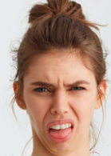  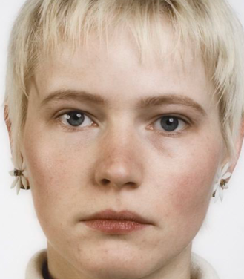 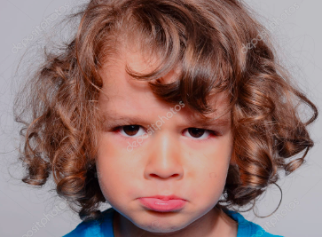 

      

***Preprocessing***

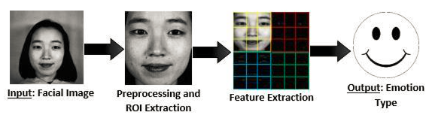

***Face detection***

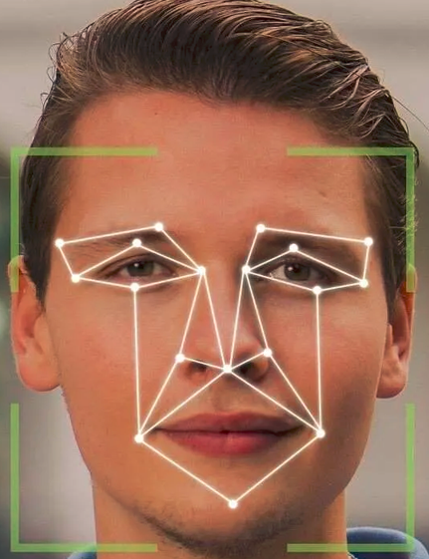 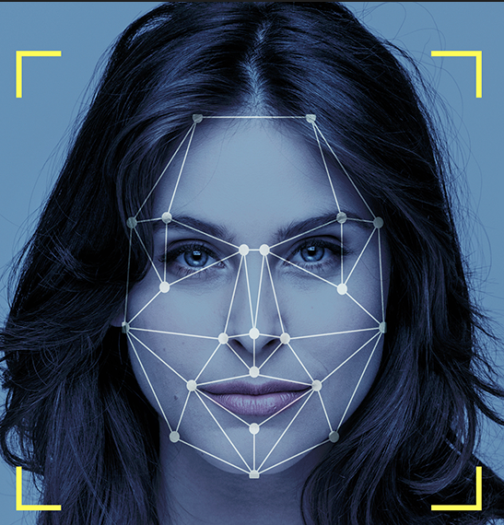 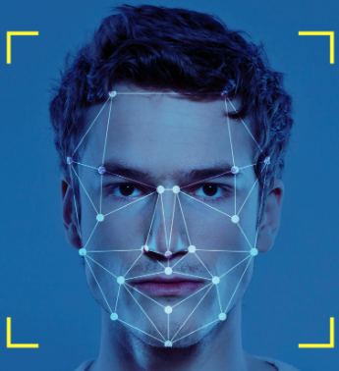

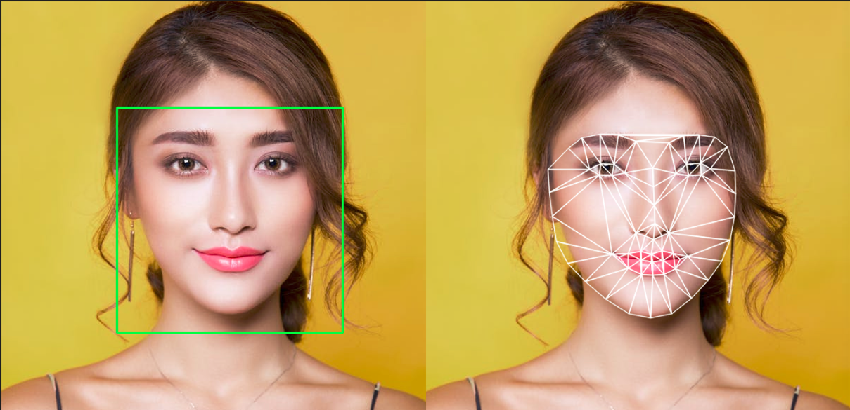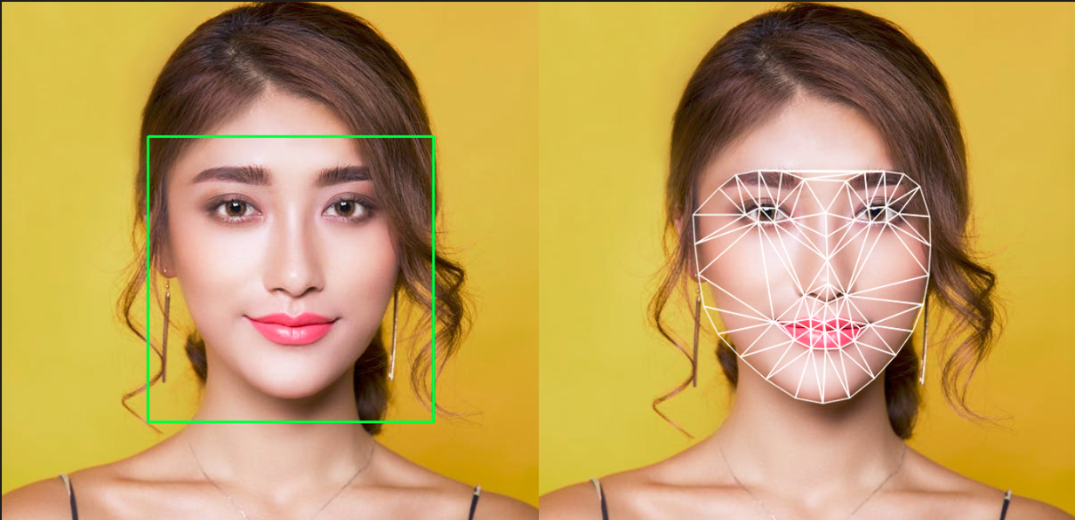

***Facial features extraction***

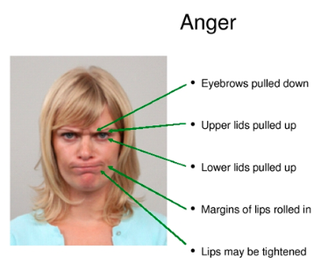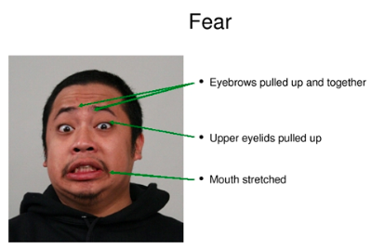

***Emotion rating***

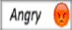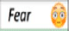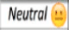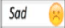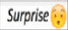

***Output / Identified Expression***

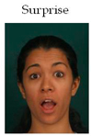 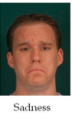 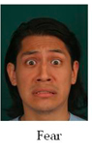  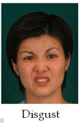

**1. Preprocessing:**

Preprocessing is fundamental step of image processing in computer vision field. The process is which can be used to improve the performance of the Face expression recognition system and it can be carried out before feature extraction process Image preprocessing includes different types of processes such as image clarity and scaling, contrast adjustment, and additional enhancement processes to improve the expression frames, by making the size of all images to 48x48 pixels. To make the model more robust to noise and slight transformations, data augmentation is employed. Each image is amplified 10 times using different linear transformations. The transformations include horizontal flip, rotation with a random angle, skewing the center area, and zooming at four corners of the image.

**2. Face detection**

First part of my system is module for face detection and landmark localization in the image. The algorithm for face detection is based on work by Viola and Jones. In this approach image is represented by a set of Haar-like features. Possible types of features are two-, three- and four- rectangular features **(Figure 6-a**).

This is computed in one pass; thus, feature can be computed rapidly because the value of each rectangle requires only 4-pixel references **(Figure 6-b).**

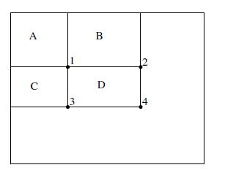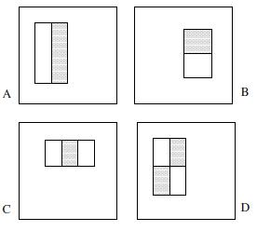

**Figure 6-b**

**Figure 6-a**

trained to decide if the image contains searched object (face) or not. The method is widely used in area of face detection. However, it can be trained to detect any object. What is more, this algorithm is quick and efficient and could be used in real-time applications. In proposed system, the algorithm is applied for

face, eyes and mouth localization with use of already trained classifiers from OpenCV library.

The face detection procedure includes some steps which are consecutively performed on the input image. Procedure flow is illustrated by the output of each function called on input image. Firstly, the classifier trained for face detection searches for a face in the image **(Figure 7)**. In case when face is not found in the image, further processing is omitted and system returns appropriate error message.

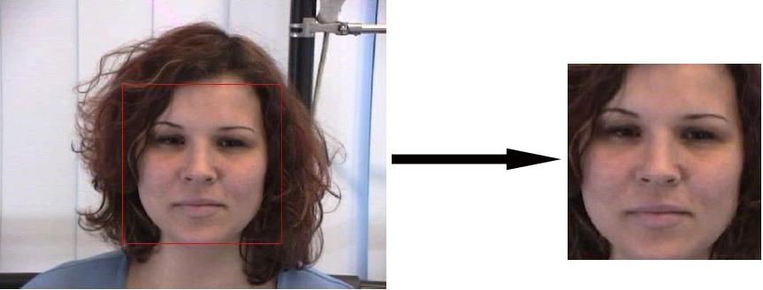

**Figure 7**

If the face is located, the classifiers for eye detections are employed only on the upper part of the face. The left and right eyes are detected separately – in left and right upper face regions **(Figure 8)**. Finally, the mouth region is located with the fourth classifier which searches in the lower part of the face. The search area of facial elements detectors is narrowed in order to improve the time efficiency of the algorithm.

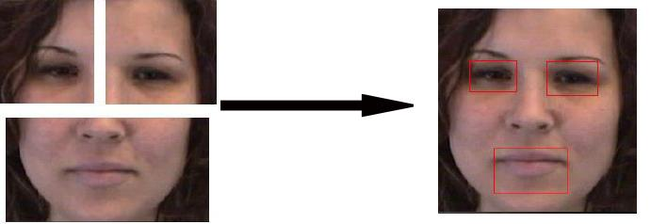

**Figure 8**

Having locations of the face and facial landmarks, the face representation can be formed. If there are more faces detected in the image, the algorithm takes the biggest one for further processing.

**3. Feature Extraction**

Facial Features extraction is an important step in face recognition and is defined as the process of locating specific regions, points, landmarks, or curves/contours in a given 2-D image or a 3D range image. In this feature extraction step, a numerical feature vector is generated from the resulting registered image. Common features that can be extracted are:

1. Lips
2. Eyes
3. Eyebrows
4. Nose tip

Simple examples of the above:

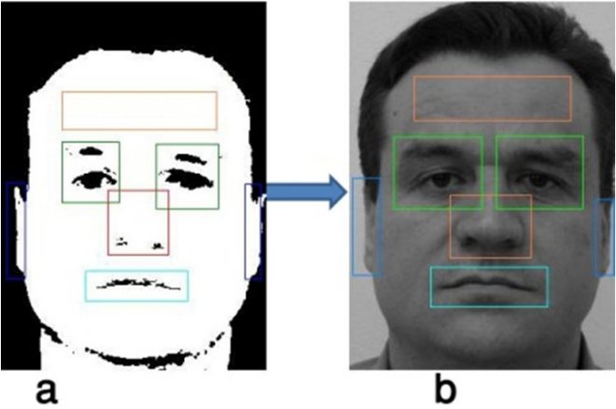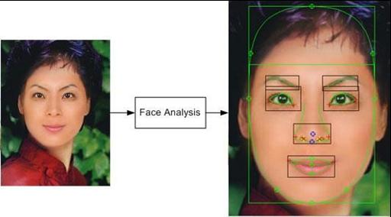

**4. Emotion Classification:**

the algorithm attempts to classify the given faces portraying one of the seven basic emotions. After extracting and preparing the most distinguished features from face images, the images are classified utilizing a particular classification technique to the appropriate class label of facial expressions. The widespread classification techniques are Deep Neural Networks (DNNs), support vector machines (SVMs), Neural Networks (NNs). The efficiency and accuracy of Face expression recognition system depends on the techniques and the algorithms of feature extraction and classification. Various technique's purpose. This section provides some techniques that have been utilized for the same purpose.

Simple examples of the above:

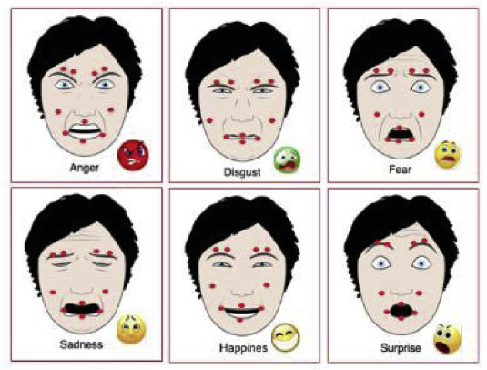



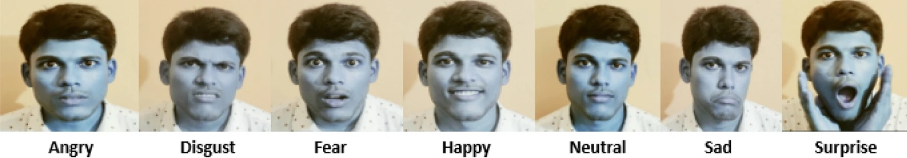

* + **2.2-DataSet**

At this project we try to make classifier to human’s specific emotions to show.

**# Dataset:**

The data consists of 48x48 pixel grayscale images of faces. The faces have been automatically registered so that the face is more or less centered and occupies about the same amount of space in each image. Each image corresponds to a facial expression in one of seven categories (0=Angry, 1=Disgust, 2=Fear, 3=Happy, 4=Sad, 5=Surprise, 6=Neutral).

The dataset contains approximately ≈28K images to train class and ≈7K images to validation class.

The original data consisted in arrays with a greyscale value for each pixel. We converted this data into raw images and splitted them in multiple folders:

**images/  
    train/  
        angry/  
        disgust/  
        fear/  
        happy/  
        neutral/  
        sad/  
        surprise/  
    validation/  
        angry/  
        disgust/  
        fear/  
        happy/  
        neutral/  
        sad/  
        surprise/**

**80% of our images are contained inside the train folder, and the last 20% are inside the validation folder.**

**#Count Number of train images for each expression:**

angry:3993

disgust:436

fear:4103

happy:7164

neutral:4982

sad:4938

surprise:3205

Total number of images: 28821

Class with the maximum number of images: happy(7164)

Class with the minimum number of images: disgust(436)

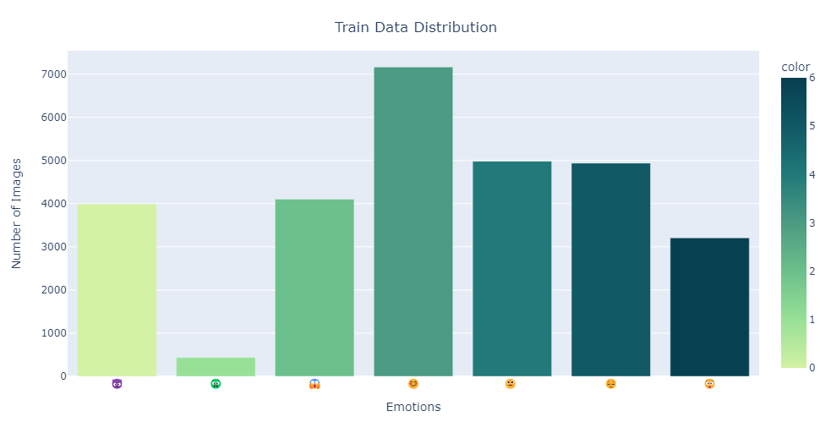

**#Count Number of validation images for each expression:**

angry:960

disgust:111

fear:1018

happy:1825

neutral:1216

sad:1139

surprise:797

Total number of images: 7066

Class with the maximum number of images: happy(1825)

Class with the minimum number of images: disgust(111)

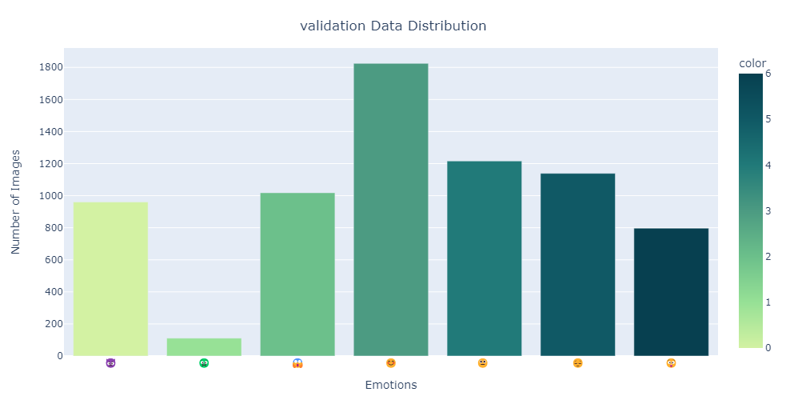

**#Summary**

We have 28,821 photos belonging to train class.

We have 7,066 photos belonging to validation class.

the maximum number of images: happy

the minimum number of images: disgust

* + **2.3-Proposed Model**

In this section, we will explain what the model did,

**We set up our Convolutional Neural Network (CNN)**

First, we used cnn in our project, what is cnn, and why did we use it??

Follow me to find out all this and more:

* **what is cnn:**

is a type of [artificial neural network](https://www.techtarget.com/searchenterpriseai/definition/neural-network) used in [image recognition](https://www.techtarget.com/searchenterpriseai/definition/image-recognition) and processing that is specifically designed to process pixel data, The algorithm select the best properties in the image, and it knows if there are any objects, and if there is an object, it will locate the exact object.

* **why did we use it?**

1. It automatically detects important features without any human supervision.
2. It identifies a human face by looking at certain previously learned features.

* **Detailed Explanation:**

We chose to use a Convolutional Neural Network in order to tackle this face recognition problem. Indeed, this type of Neural Network (NN) is good for extracting the features of images and is widely used for image analysis subjects like image classification.

* **Quick reminder of what a NN is:**

A Neural Network is a learning framework that consists in multiple layers of artificial neurons (nodes). Each node gets weighted input data, passes it into an activation function and outputs the result of the

**A NN is composed of several layers of nodes:**

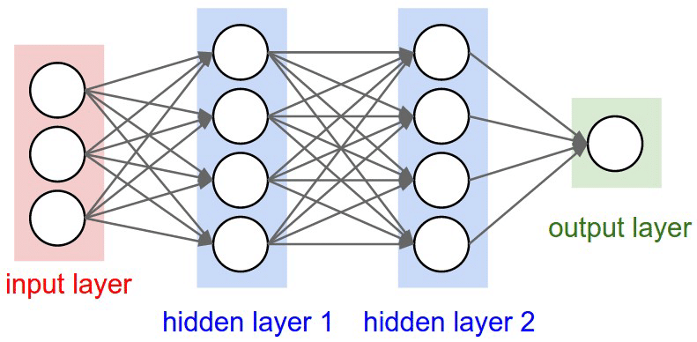

An input layer that will get the data. The size of the input layer depends on the size of the input data.

Some hidden layers that will allow the NN to learn complex interactions within the data. A Neural Network with a lot of hidden layers is called a Deep Neural Network.

An output layer that will give the final result, for instance a class prediction. The size of this layer depends on the type of output we want to produce.

**Note!!**

1. Classic NNs are usually composed of several fully connected layers. This means that every neuron of one layer is connected to every neuron of the next layer.
2. Convolutional Neural Networks also have Convolutional layers that apply sliding functions to group of pixels that are next to each other. Therefore, those structures have a better understanding of patterns that we can observe in images.
3. Our CNN is defined by the following global architecture:

4 convolutional layers

2 fully connected layer

We have chosen the layered desks that we will be using in our project, we are going to write them now and then I will explain each one individually.

from keras.layers import Dense, Dropout, Flatten, Conv2D, BatchNormalization, Activation, MaxPooling2D

from keras.models import Sequential

from tensorflow.keras.optimizers import Adam

**#Model Building**

**Model:**

**Dense:** Dense layer is the regular deeply connected neural network layer. It is most common and frequently used layer. Dense layer does the below operation on the input and return the output.

**Dropout:** Dropout is a technique used to prevent a model from overfitting. Dropout works by randomly setting the outgoing edges of hidden units (neurons that make up hidden layers) to 0 at each update of the training phase. We chose softmax as our last activation function as it is commonly used for multi-label classification.

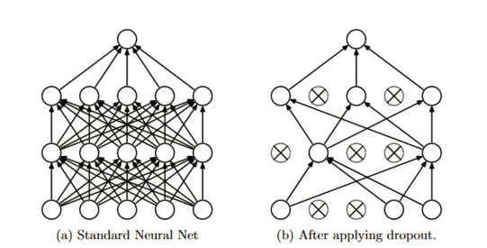

**Flatten:** Converting the Matrix to Vector.

**Conv2D:** Keras Conv2D is a 2D Convolution Layer, this layer creates a convolution kernel that is wind with layers input which helps produce a tensor of outputs.

**Batch normalization:** improves the performance and stability of NNs by providing inputs with zero mean and unit variance, a technique for training very deep neural networks that standardizes the inputs to a layer for each mini-batch. This has the effect of stabilizing the learning process and dramatically reducing the number of training epochs required to train deep networks.

**Activation:**

**relu:** The rectified linear activation function or ReLU for short is a piecewise linear function that will output the input directly if it is positive, otherwise, it will output zero. It has become the default activation function for many types of neural networks because a model that uses it is easier to train and often achieves better performance.

**Maxpooling:** Maximum pooling, or max pooling, is a pooling operation that calculates the maximum, or largest, value in each patch of each feature map. The results are down sampled or pooled feature maps that highlight the most present feature in the patch, not the average presence of the feature in the case of average pooling.

**sequential:** A Sequential model is appropriate for a plain stack of layers where each layer has exactly one input tensor and one output tensor.

**Adam:** Adam optimizer as it is one of the most computationally effective.

**We will explain more information:**

**padding:** The padding parameter of the Keras Conv2D class can take one of two values: 'valid' or 'same'. Setting the value to “valid” parameter means that the input volume is not zero-padded and the spatial dimensions are allowed to reduce via the natural application of convolution.

**input_shape=(56, 56,1)**

**56, 56**: size the image

**1**: color the Image (1: GRAY, 3: RGB)

**We chose the categorical cross-entropy** as our loss function as it is quite relevant for classification tasks.

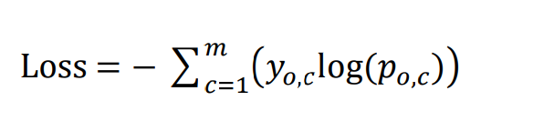

Where:

**y** is a binary indicator (0 or 1),

**p** is the predicted probability,

**m** is the number of classes (angry/disgust/fear/happy/neutral/sad/surprise) = 7

**Our metric will be the accuracy**, which is also quite informative for classification tasks on balanced datasets.

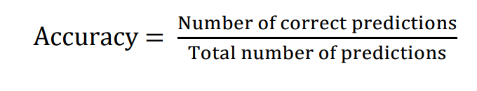

**Let's explain a little bit about the second algorithm that we will use Description vgg16:**

VGG-16 is a convolutional neural network that is 16 layers deep. You can load a pretrained version of the network trained on more than a million images from the ImageNet database . The pretrained network can classify images into 1000 object categories, such As a result, the network has learned rich feature representations for a wide range of images. The network has an image input size of 224-by-224.

**Step by step VGG16 implementation in Keras:**

VGG16 is a convolution neural net (CNN) It is considered to be one of the excellent vision model architecture till date. Most unique thing about VGG16 is that instead of having a large number of hyper-parameter they focused on having convolution layers of 3x3 filter with a stride 1 and always used same padding and maxpool layer of 2x2 filter of stride 2. It follows this arrangement of convolution and max pool layers consistently throughout the whole architecture. In the end it has 2 FC(fully connected layers) followed by a softmax for output. The 16 in VGG16 refers to it has 16 layers that have weights. This network is a pretty large network and it has about 138 million (approx) parameters.

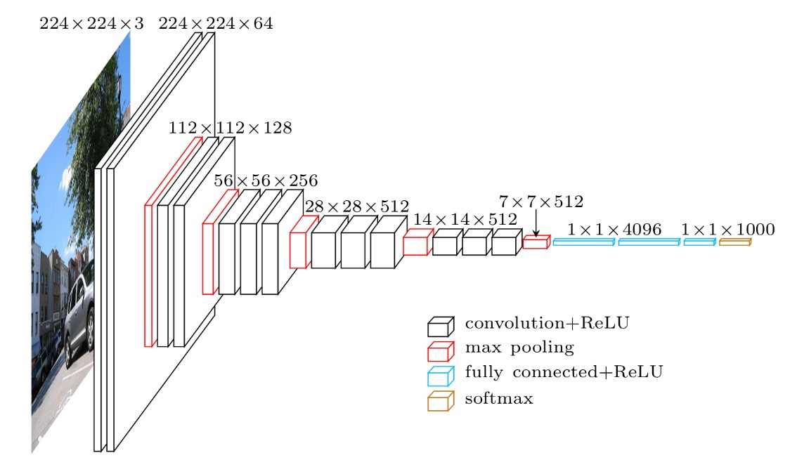

**#3. Experimental Results**

Since we have come to this point, we must present the results of our project and compare them with the other model to see if our model is good or bad.

We will show you the information that remained constant in our project during the change in the number of epochs in the first model and the second model

‏

|  |  |
| --- | --- |
| **the First project(CNN)** | **the second project(VGG16)** |
| **the number of parameters we have:**    Total parameters: 4,478,727  Trainable parameters: 4,474,759  Non-trainable parameters: 3968 | **the number of parameters we have:**  Total params: 6,981,895  Trainable params: 6,976,903  Non-trainable params: 4,992 |

We will show you **the information that changed** in our project during the change in the number of epochs in the first model and the second model.

**Epochs 3 (CNN):**

|  |  |  |  |
| --- | --- | --- | --- |
| **loss** | **accuracy** | **val_loss** | **val_accuracy** |
| 1.8565 | 0.2611 | 1.8179 | 0.2747 |

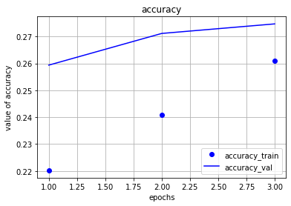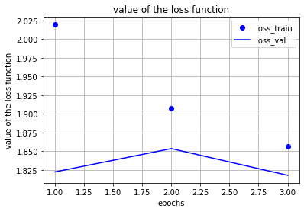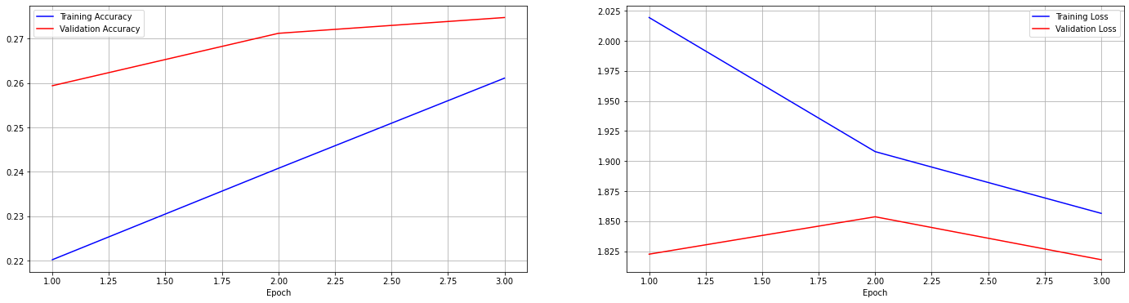

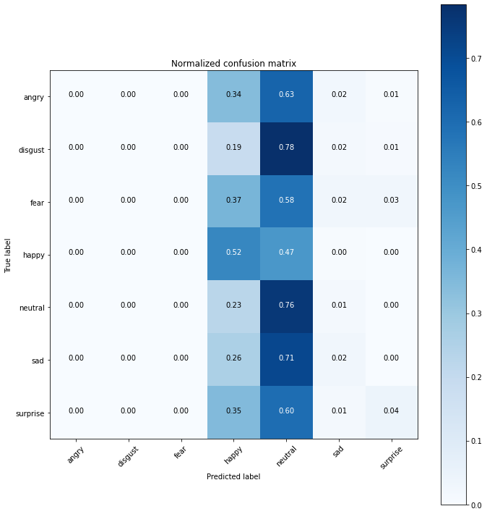

|  |  |  |  |  |
| --- | --- | --- | --- | --- |
| **support** | **f1-score** | **recal** | **precision** |  |
| 960 | 0 | 0 | 0.2 | **angry** |
| 111 | 0 | 0 | 0 | **disgust** |
| 1018 | 0 | 0 | 0 | **fear** |
| 1825 | 0.44 | 0.52 | 0.38 | **happy** |
| 1216 | 0.33 | 0.76 | 0.21 | **neutral** |
| 1139 | 0.04 | 0.02 | 0.25 | **sad** |
| 797 | 0.07 | 0.04 | 0.42 | **surprise** |
|  |  |  |  |  |
| 7066 | 0.27 |  |  | **accuracy** |
| 7066 | 0.13 | 0.19 | 0.21 | **macro avg** |
| 7066 | 0.19 | 0.27 | 0.25 | **weighted avg** |

**Epochs 3 (Vgg-16):**

|  |  |  |  |
| --- | --- | --- | --- |
| **loss** | **accuracy** | **val_loss** | **val_accuracy** |
| 2.0215 | 0.2521 | 1.8112 | 0.2885 |

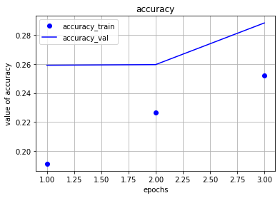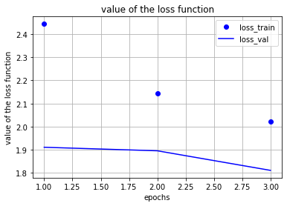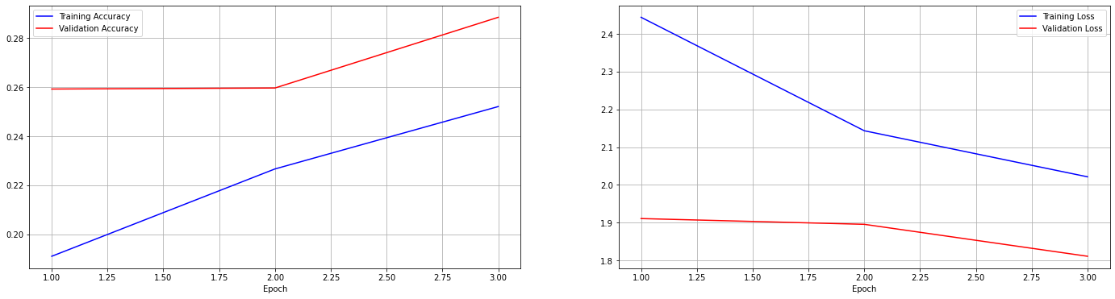

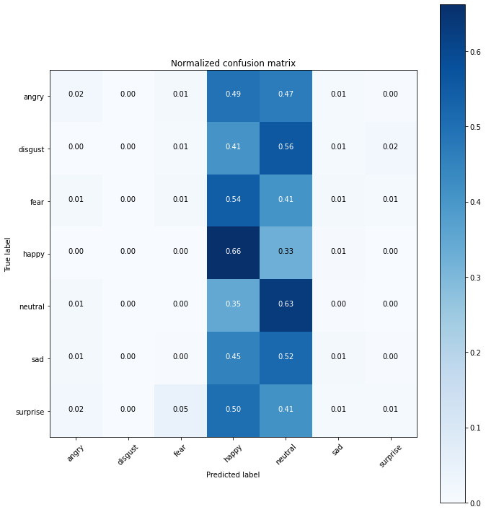

|  |  |  |  |  |
| --- | --- | --- | --- | --- |
| **support** | **f1-score** | **recal** | **precision** |  |
| 960 | 0.03 | 0.02 | 0.21 | **angry** |
| 111 | 0.00 | 0.00 | 0.00 | **disgust** |
| 1018 | 0.03 | 0.01 | 0.21 | **fear** |
| 1825 | 0.44 | 0.66 | 0.33 | **happy** |
| 1216 | 0.35 | 0.63 | 0.24 | **neutral** |
| 1139 | 0.03 | 0.01 | 0.26 | **sad** |
| 797 | 0.02 | 0.01 | 0.30 | **surprise** |
|  |  |  |  |  |
| 7066 | 0.29 |  |  | **accuracy** |
| 7066 | 0.13 | 0.19 | 0.22 | **macro avg** |
| 7066 | 0.19 | 0.29 | 0.26 | **weighted avg** |

**Epochs 5 (CNN):**

|  |  |  |  |
| --- | --- | --- | --- |
| **loss** | **accuracy** | **val_loss** | **val_accuracy** |
| 1.7789 | 0.2987 | 1.6766 | 0.3463 |

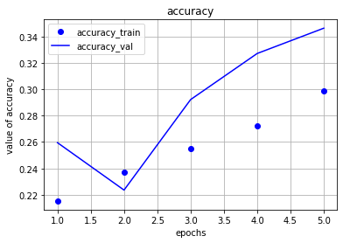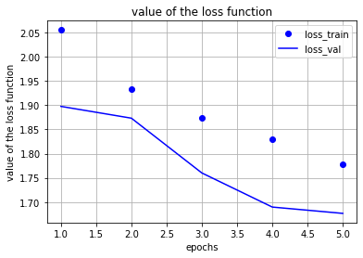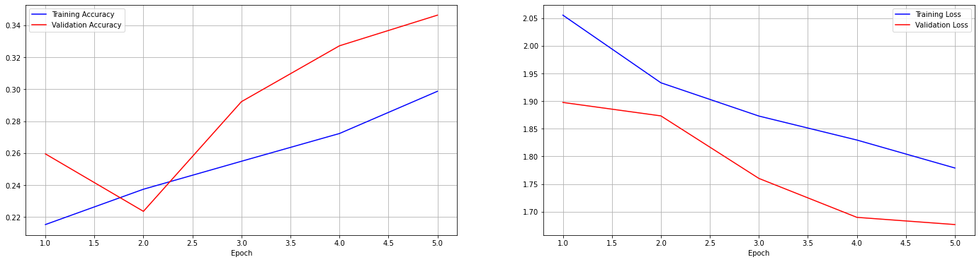

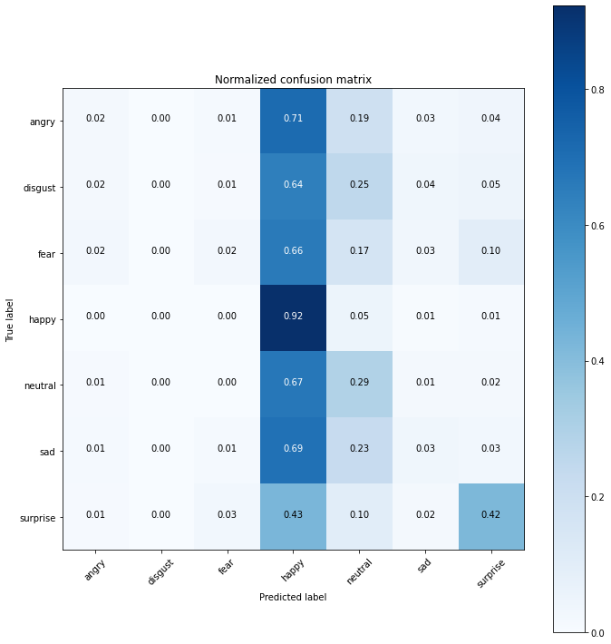

|  |  |  |  |  |
| --- | --- | --- | --- | --- |
| **support** | **f1-score** | **recal** | **precision** |  |
| 960 | 0.03 | 0.02 | 0.21 | **angry** |
| 111 | 0.00 | 0.00 | 0.00 | **disgust** |
| 1018 | 0.05 | 0.02 | 0.30 | **fear** |
| 1825 | 0.49 | 0.92 | 0.33 | **happy** |
| 1216 | 0.30 | 0.29 | 0.31 | **neutral** |
| 1139 | 0.06 | 0.03 | 0.26 | **sad** |
| 797 | 0.50 | 0.42 | 0.61 | **surprise** |
|  |  |  |  |  |
| 7066 | 0.35 |  |  | **accuracy** |
| 7066 | 0.20 | 0.24 | 0.29 | **macro avg** |
| 7066 | 0.25 | 0.35 | 0.32 | **weighted avg** |

**Epochs 5 (Vgg-16):**

|  |  |  |  |
| --- | --- | --- | --- |
| **loss** | **accuracy** | **val_loss** | **val_accuracy** |
| 1.8827 | 0.2919 | 1.6724 | 0.3469 |

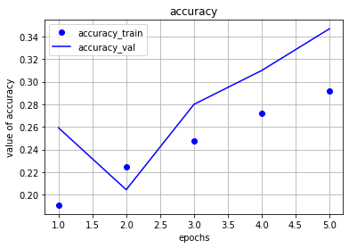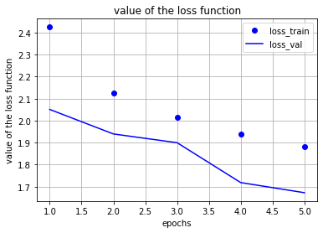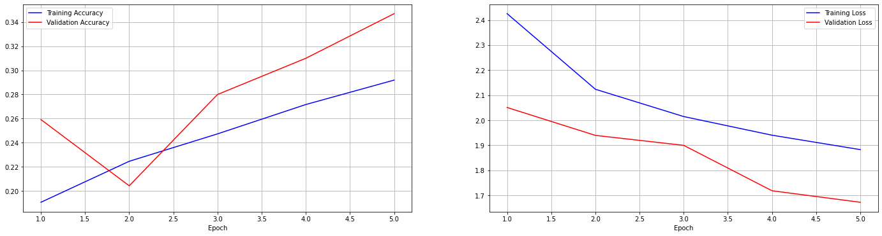

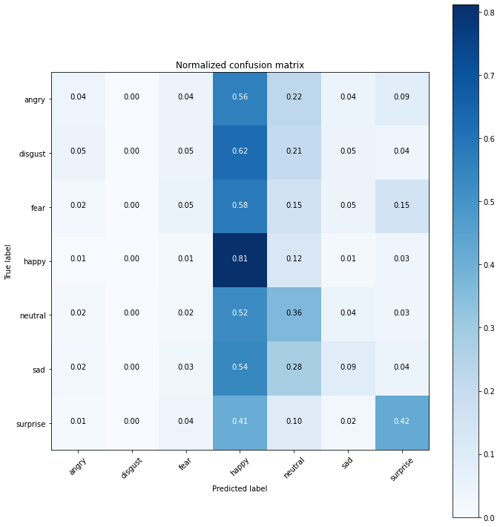

|  |  |  |  |  |
| --- | --- | --- | --- | --- |
| **support** | **f1-score** | **recal** | **precision** |  |
| 960 | 0.07 | 0.04 | 0.29 | **angry** |
| 111 | 0.00 | 0.00 | 0.00 | **disgust** |
| 1018 | 0.08 | 0.05 | 0.24 | **fear** |
| 1825 | 0.49 | 0.81 | 0.35 | **happy** |
| 1216 | 0.33 | 0.36 | 0.31 | **neutral** |
| 1139 | 0.15 | 0.09 | 0.36 | **sad** |
| 797 | 0.44 | 0.42 | 0.46 | **surprise** |
|  |  |  |  |  |
| 7066 | 0.35 |  |  | **accuracy** |
| 7066 | 0.22 | 0.25 | 0.29 | **macro avg** |
| 7066 | 0.28 | 0.35 | 0.33 | **weighted avg** |

**Epochs 10 (CNN):**

|  |  |  |  |
| --- | --- | --- | --- |
| **loss** | **accuracy** | **val_loss** | **val_accuracy** |
| 1.5713 | 0.3868 | 1.4396 | 0.4411 |

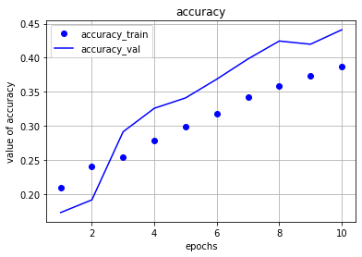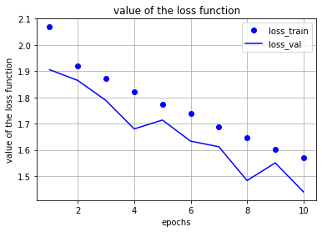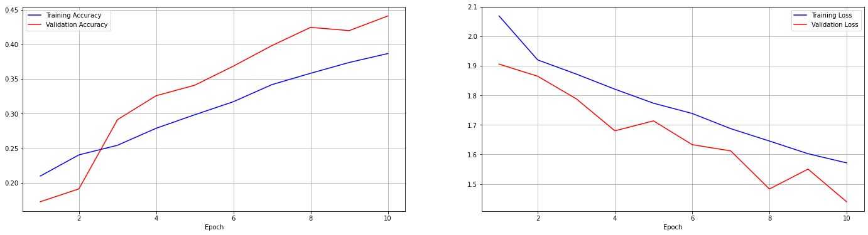

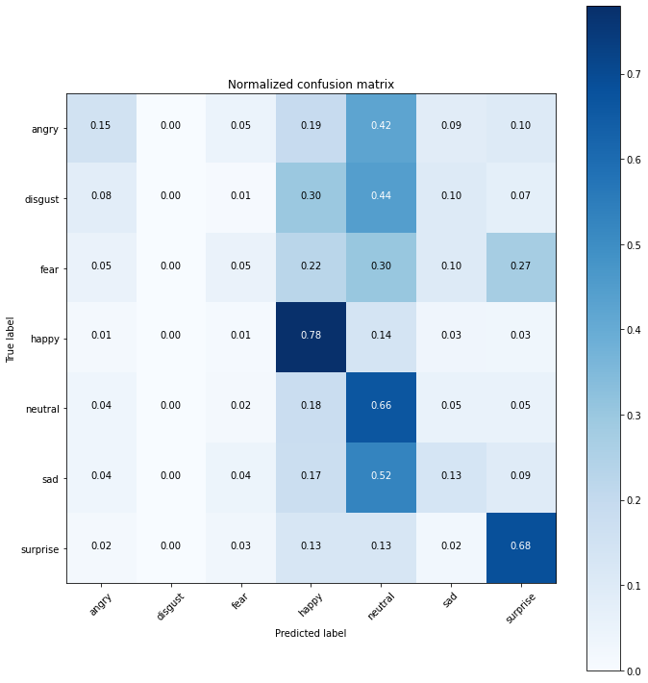

|  |  |  |  |  |
| --- | --- | --- | --- | --- |
| **support** | **f1-score** | **recal** | **precision** |  |
| 960 | 0.23 | 0.15 | 0.44 | **angry** |
| 111 | 0.00 | 0.00 | 0.00 | **disgust** |
| 1018 | 0.09 | 0.05 | 0.25 | **fear** |
| 1825 | 0.68 | 0.78 | 0.60 | **happy** |
| 1216 | 0.43 | 0.66 | 0.32 | **neutral** |
| 1139 | 0.19 | 0.13 | 0.31 | **sad** |
| 797 | 0.56 | 0.68 | 0.47 | **surprise** |
|  |  |  |  |  |
| 7066 | 0.44 |  |  | **accuracy** |
| 7066 | 0.31 | 0.35 | 0.34 | **macro avg** |
| 7066 | 0.39 | 0.44 | 0.41 | **weighted avg** |

**Epochs 10 (Vgg-16):**

|  |  |  |  |
| --- | --- | --- | --- |
| **loss** | **accuracy** | **val_loss** | **val_accuracy** |
| 1.6344 | 0.3885 | 1.4951 | 0.4354 |

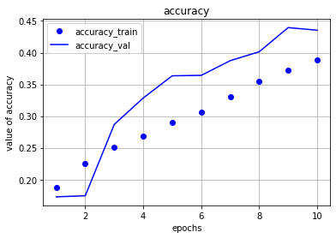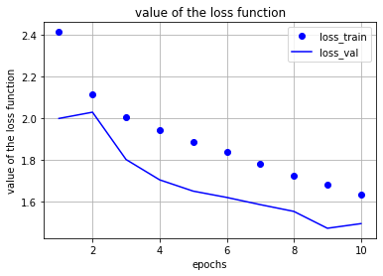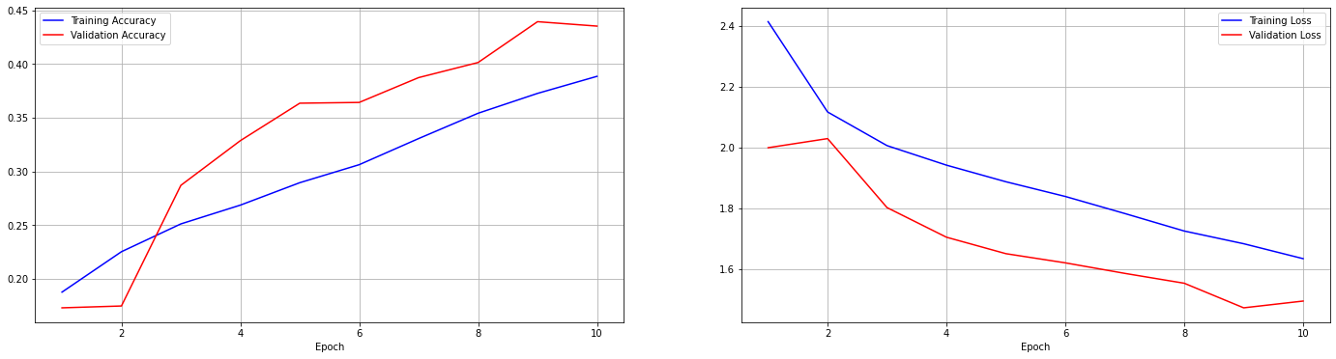

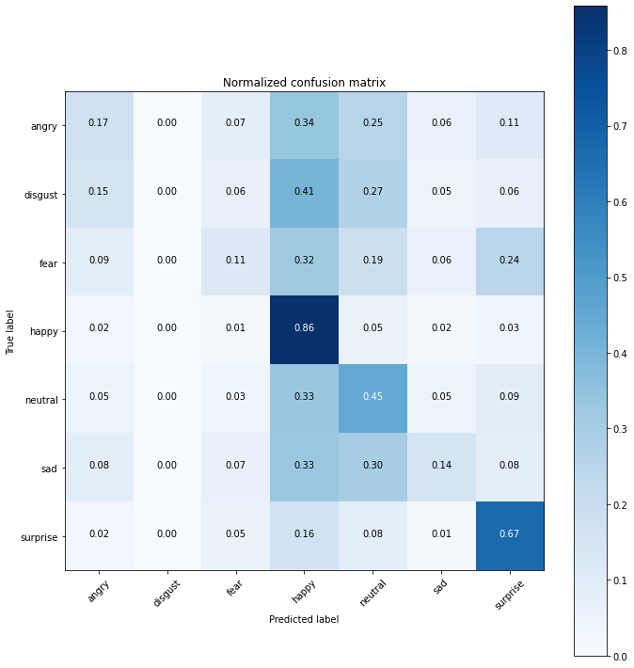

|  |  |  |  |  |
| --- | --- | --- | --- | --- |
| **support** | **f1-score** | **recal** | **precision** |  |
| 960 | 0.23 | 0.17 | 0.34 | **angry** |
| 111 | 0.00 | 0.00 | 0.00 | **disgust** |
| 1018 | 0.16 | 0.11 | 0.30 | **fear** |
| 1825 | 0.63 | 0.88 | 0.50 | **happy** |
| 1216 | 0.40 | 0.45 | 0.36 | **neutral** |
| 1139 | 0.21 | 0.16 | 0.42 | **sad** |
| 797 | 0.55 | 0.67 | 0.46 | **surprise** |
|  |  |  |  |  |
| 7066 | 0.44 |  |  | **accuracy** |
| 7066 | 0.31 | 0.34 | 0.34 | **macro avg** |
| 7066 | 0.28 | 0.44 | 0.40 | **weighted avg** |

**Epochs 25 (CNN):**

|  |  |  |  |
| --- | --- | --- | --- |
| **loss** | **accuracy** | **val_loss** | **val_accuracy** |
| 1.2489 | 0.5229 | 1.1364 | 0.5722 |

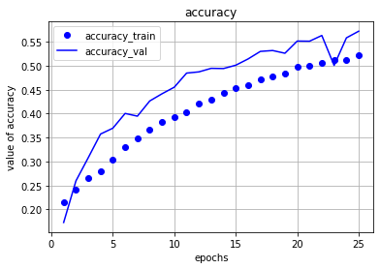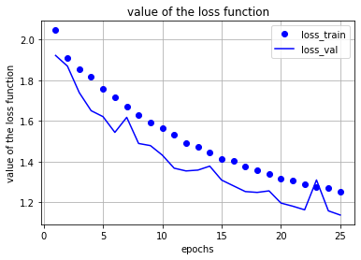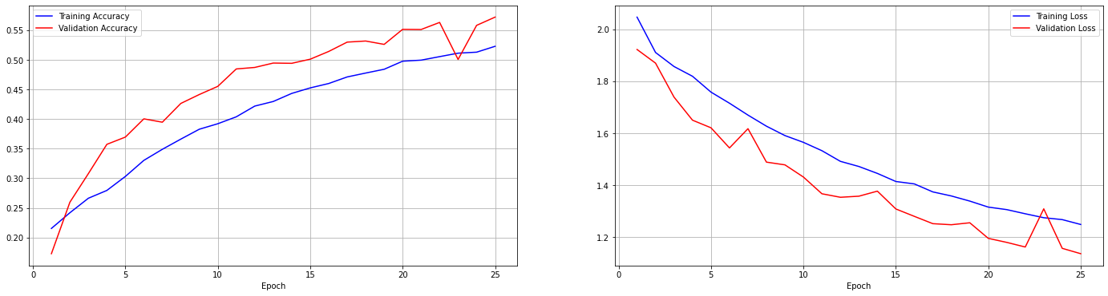

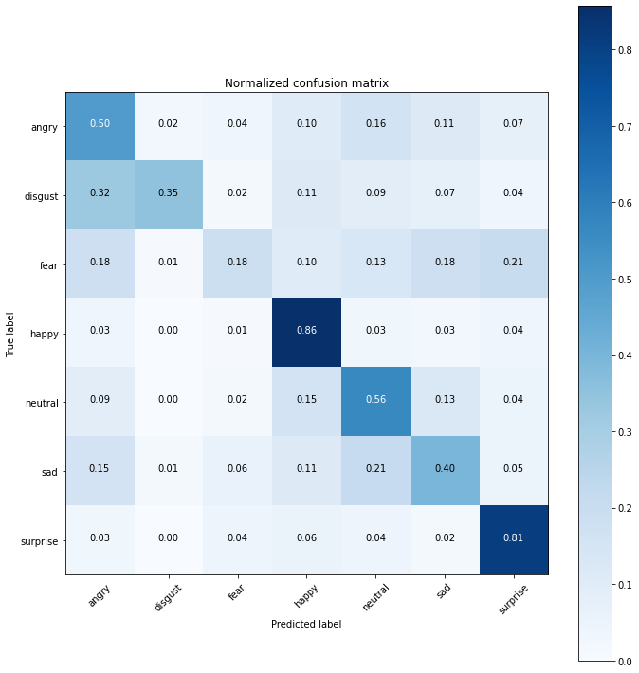

|  |  |  |  |  |
| --- | --- | --- | --- | --- |
| **support** | **f1-score** | **recal** | **precision** |  |
| 960 | 0.47 | 0.50 | 0.44 | **angry** |
| 111 | 0.38 | 0.35 | 0.41 | **disgust** |
| 1018 | 0.27 | 0.18 | 0.52 | **fear** |
| 1825 | 0.79 | 0.86 | 0.73 | **happy** |
| 1216 | 0.54 | 0.56 | 0.52 | **neutral** |
| 1139 | 0.43 | 0.40 | 0.47 | **sad** |
| 797 | 0.68 | 0.81 | 0.58 | **surprise** |
|  |  |  |  |  |
| 7066 | 0.57 |  |  | **accuracy** |
| 7066 | 0.51 | 0.52 | 0.52 | **macro avg** |
| 7066 | 0.55 | 0.57 | 0.56 | **weighted avg** |

**Epochs 25 (Vgg-16):**

|  |  |  |  |
| --- | --- | --- | --- |
| **loss** | **accuracy** | **val_loss** | **val_accuracy** |
| 1.2820 | 0.5198 | 1.2104 | 0.5416 |

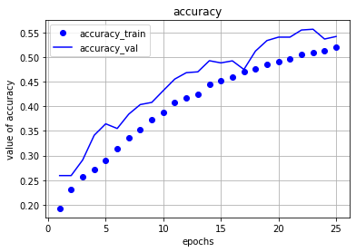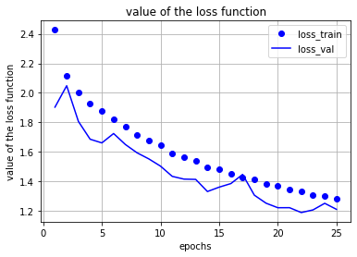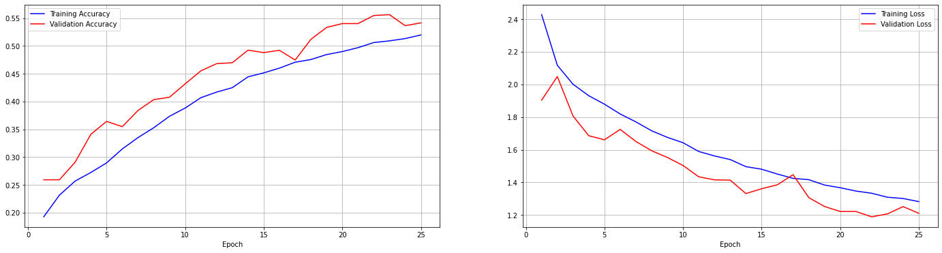

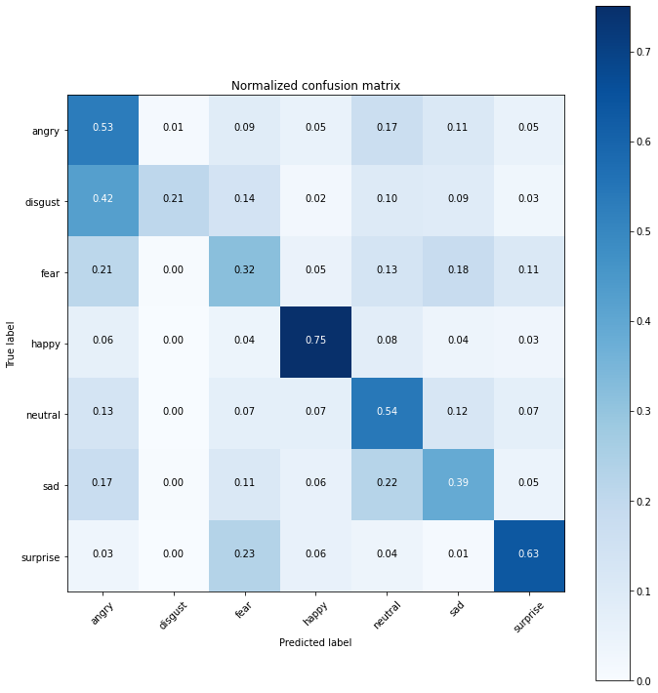

|  |  |  |  |  |
| --- | --- | --- | --- | --- |
| **support** | **f1-score** | **recal** | **precision** |  |
| 960 | 0.46 | 0.53 | 0.40 | **angry** |
| 111 | 0.30 | 0.21 | 0.53 | **disgust** |
| 1018 | 0.34 | 0.32 | 0.37 | **fear** |
| 1825 | 0.79 | 0.75 | 0.82 | **happy** |
| 1216 | 0.50 | 0.54 | 0.47 | **neutral** |
| 1139 | 0.42 | 0.39 | 0.46 | **sad** |
| 797 | 0.61 | 0.63 | 0.59 | **surprise** |
|  |  |  |  |  |
| 7066 | 0.54 |  |  | **accuracy** |
| 7066 | 0.49 | 0.48 | 0.52 | **macro avg** |
| 7066 | 0.54 | 0.54 | 0.55 | **weighted avg** |

**Epochs 50 (CNN):**

|  |  |  |  |
| --- | --- | --- | --- |
| **loss** | **accuracy** | **val_loss** | **val_accuracy** |
| 1.0678 | 0.5927 | 1.0497 | 0.6048 |

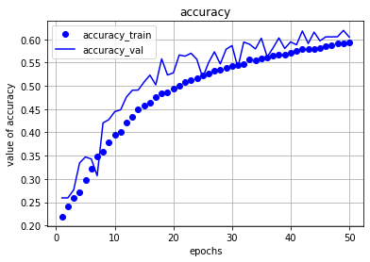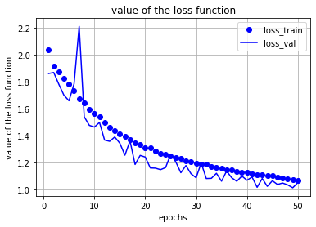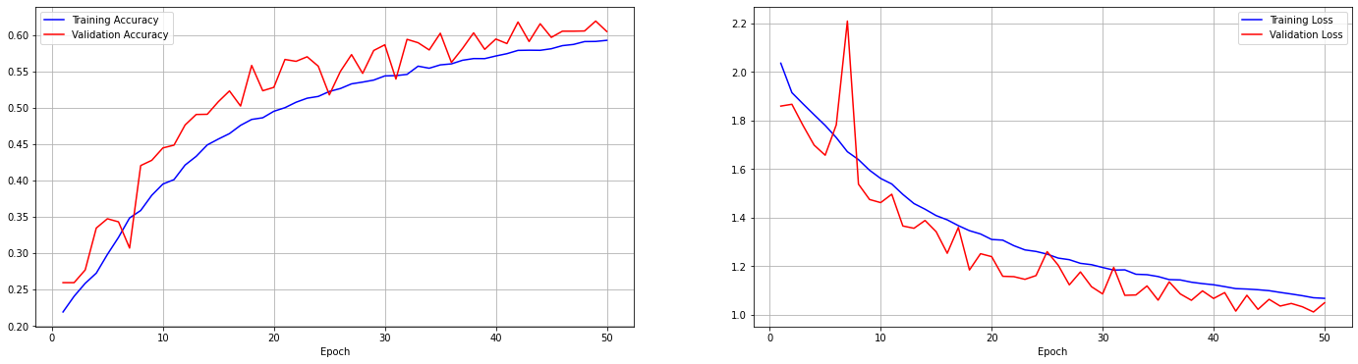

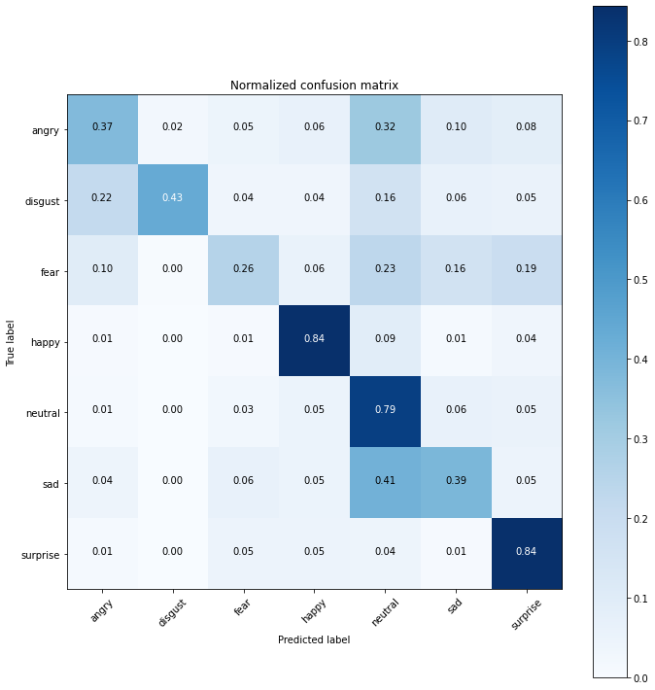

|  |  |  |  |  |
| --- | --- | --- | --- | --- |
| **support** | **f1-score** | **recal** | **precision** |  |
| 960 | 0.47 | 0.37 | 0.63 | **angry** |
| 111 | 0.52 | 0.43 | 0.66 | **disgust** |
| 1018 | 0.35 | 0.26 | 0.56 | **fear** |
| 1825 | 0.84 | 0.84 | 0.85 | **happy** |
| 1216 | 0.57 | 0.79 | 0.44 | **neutral** |
| 1139 | 0.45 | 0.39 | 0.54 | **sad** |
| 797 | 0.69 | 0.84 | 0.59 | **surprise** |
|  |  |  |  |  |
| 7066 | 0.61 |  |  | **accuracy** |
| 7066 | 0.56 | 0.56 | 0.61 | **macro avg** |
| 7066 | 0.59 | 0.61 | 0.62 | **weighted avg** |

**Epochs 50 (Vgg-16):**

|  |  |  |  |
| --- | --- | --- | --- |
| **loss** | **accuracy** | **val_loss** | **val_accuracy** |
| 1.0265 | 0.6095 | 1.0812 | 0.6074 |

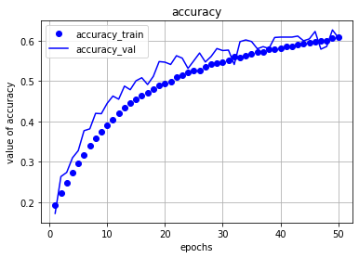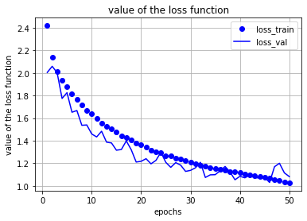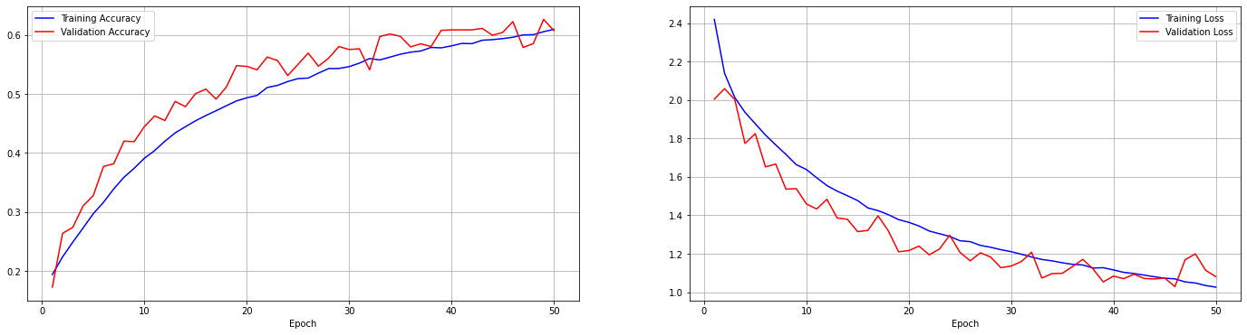

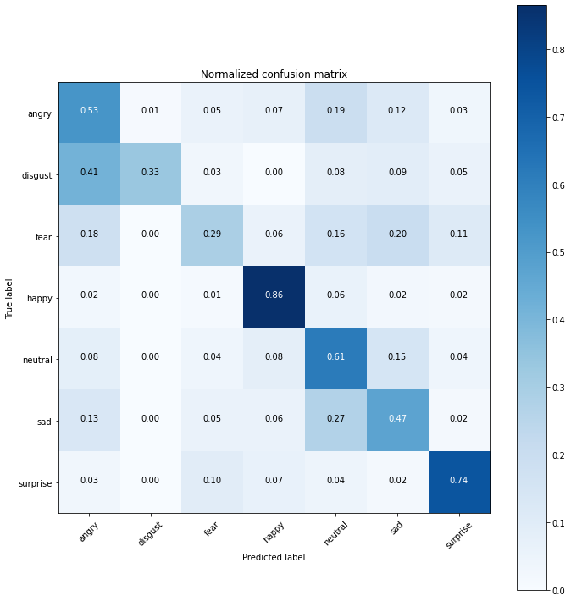

|  |  |  |  |  |
| --- | --- | --- | --- | --- |
| **support** | **f1-score** | **recal** | **precision** |  |
| 960 | 0.50 | 0.53 | 0.48 | **angry** |
| 111 | 0.74 | 0.33 | 0.79 | **disgust** |
| 1018 | 0.37 | 0.29 | 0.53 | **fear** |
| 1825 | 0.84 | 0.86 | 0.82 | **happy** |
| 1216 | 0.84 | 0.61 | 0.48 | **neutral** |
| 1139 | 0.54 | 0.47 | 0.49 | **sad** |
| 797 | 0.72 | 0.74 | 0.70 | **surprise** |
|  |  |  |  |  |
| 7066 | 0.61 |  |  | **accuracy** |
| 7066 | 0.56 | 0.55 | 0.61 | **macro avg** |
| 7066 | 0.60 | 0.61 | 0.61 | **weighted avg** |

Before concluding, I will show if I change the learning rate value, will something change or not, continue with me, in this example I will only **change the learning rate value in 3 Epochs** for illustration **only**:

**Epochs 3 (CNN) – lr = 0.0001:**

|  |  |  |  |
| --- | --- | --- | --- |
| **loss** | **accuracy** | **val_loss** | **val_accuracy** |
| 1.8565 | 0.2611 | 1.8179 | 0.2747 |





|  |  |  |  |  |
| --- | --- | --- | --- | --- |
| **support** | **f1-score** | **recal** | **precision** |  |
| 960 | 0 | 0 | 0.2 | **angry** |
| 111 | 0 | 0 | 0 | **disgust** |
| 1018 | 0 | 0 | 0 | **fear** |
| 1825 | 0.44 | 0.52 | 0.38 | **happy** |
| 1216 | 0.33 | 0.76 | 0.21 | **neutral** |
| 1139 | 0.04 | 0.02 | 0.25 | **sad** |
| 797 | 0.07 | 0.04 | 0.42 | **surprise** |
|  |  |  |  |  |
| 7066 | 0.27 |  |  | **accuracy** |
| 7066 | 0.13 | 0.19 | 0.21 | **macro avg** |
| 7066 | 0.19 | 0.27 | 0.25 | **weighted avg** |

**Epochs 3 (Vgg-16) - lr = 0.0001:**

|  |  |  |  |
| --- | --- | --- | --- |
| **loss** | **accuracy** | **val_loss** | **val_accuracy** |
| 2.0215 | 0.2521 | 1.8112 | 0.2885 |





|  |  |  |  |  |
| --- | --- | --- | --- | --- |
| **support** | **f1-score** | **recal** | **precision** |  |
| 960 | 0.03 | 0.02 | 0.21 | **angry** |
| 111 | 0.00 | 0.00 | 0.00 | **disgust** |
| 1018 | 0.03 | 0.01 | 0.21 | **fear** |
| 1825 | 0.44 | 0.66 | 0.33 | **happy** |
| 1216 | 0.35 | 0.63 | 0.24 | **neutral** |
| 1139 | 0.03 | 0.01 | 0.26 | **sad** |
| 797 | 0.02 | 0.01 | 0.30 | **surprise** |
|  |  |  |  |  |
| 7066 | 0.29 |  |  | **accuracy** |
| 7066 | 0.13 | 0.19 | 0.22 | **macro avg** |
| 7066 | 0.19 | 0.29 | 0.26 | **weighted avg** |

**Epochs 3 (CNN) - lr = 0.001:**

|  |  |  |  |
| --- | --- | --- | --- |
| **loss** | **accuracy** | **val_loss** | **val_accuracy** |
| 1.4503 | 0.4412 | 1.6721 | 0.4216 |

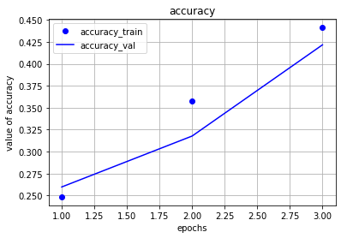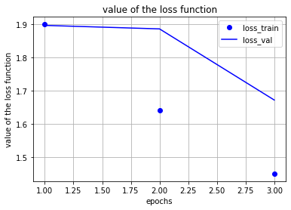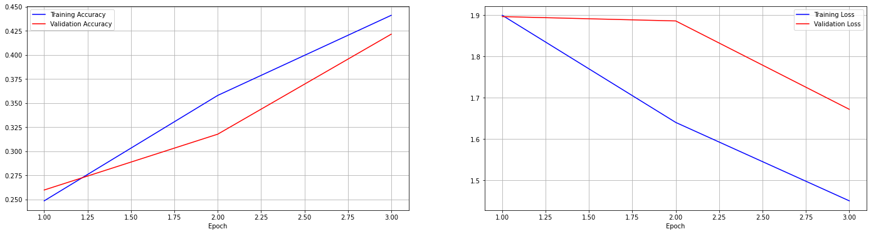

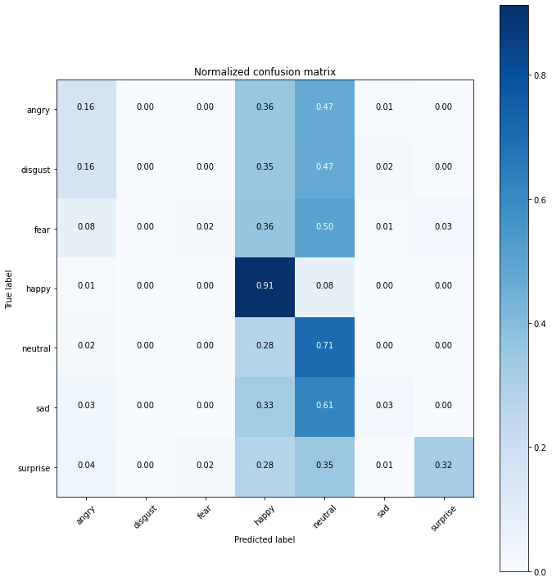

|  |  |  |  |  |
| --- | --- | --- | --- | --- |
| **support** | **f1-score** | **recal** | **precision** |  |
| 960 | 0.23 | 0.16 | 0.44 | **angry** |
| 111 | 0.00 | 0.00 | 0.00 | **disgust** |
| 1018 | 0.04 | 0.02 | 0.53 | **fear** |
| 1825 | 0.64 | 0.91 | 0.50 | **happy** |
| 1216 | 0.41 | 0.71 | 0.29 | **neutral** |
| 1139 | 0.05 | 0.03 | 0.51 | **sad** |
| 797 | 0.47 | 0.32 | 0.87 | **surprise** |
|  |  |  |  |  |
| 7066 | 0.42 |  |  | **accuracy** |
| 7066 | 0.26 | 0.31 | 0.45 | **macro avg** |
| 7066 | 0.33 | 0.42 | 0.49 | **weighted avg** |

**Epochs 3 (Vgg-16) - lr = 0.001:**

|  |  |  |  |
| --- | --- | --- | --- |
| **loss** | **accuracy** | **val_loss** | **val_accuracy** |
| 1.5589 | 0.4138 | 1.6120 | 0.3736 |

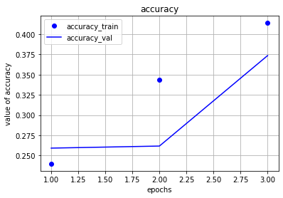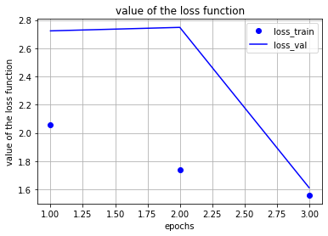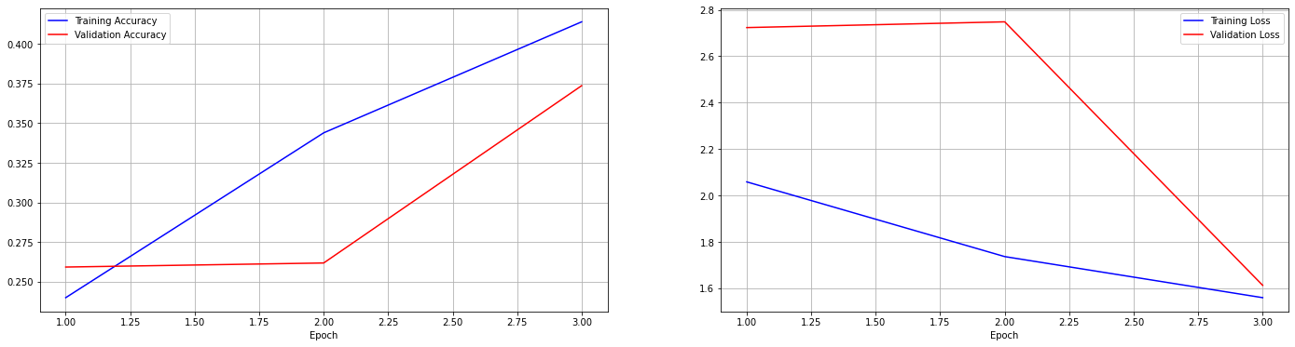

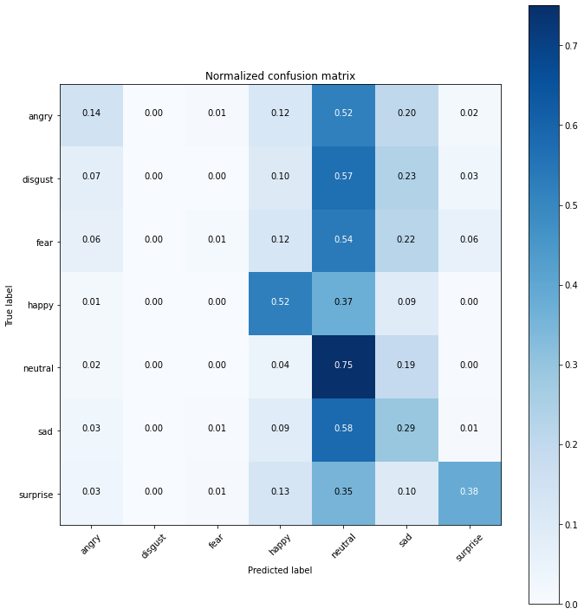

|  |  |  |  |  |
| --- | --- | --- | --- | --- |
| **support** | **f1-score** | **recal** | **precision** |  |
| 960 | 0.21 | 0.14 | 0.44 | **angry** |
| 111 | 0.00 | 0.00 | 0.00 | **disgust** |
| 1018 | 0.02 | 0.01 | 0.35 | **fear** |
| 1825 | 0.45 | 0.52 | 0.66 | **happy** |
| 1216 | 0.38 | 0.75 | 0.25 | **neutral** |
| 1139 | 0.28 | 0.29 | 0.27 | **sad** |
| 797 | 0.51 | 0.38 | 0.76 | **surprise** |
|  |  |  |  |  |
| 7066 | 0.37 |  |  | **accuracy** |
| 7066 | 0.28 | 0.30 | 0.39 | **macro avg** |
| 7066 | 0.35 | 0.37 | 0.45 | **weighted avg** |

**Epochs 3 (CNN) - lr = 0.01:**

|  |  |  |  |
| --- | --- | --- | --- |
| **loss** | **accuracy** | **val_loss** | **val_accuracy** |
| 1.5058 | 0.4113 | 1.7059 | 0.2962 |

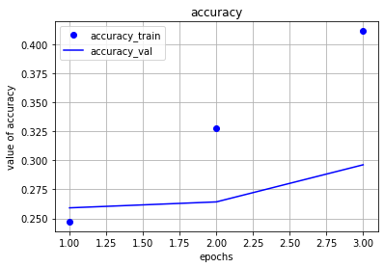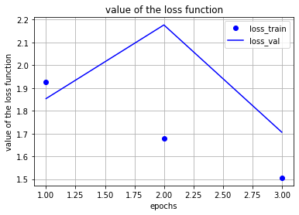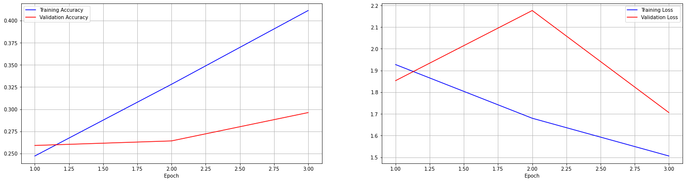

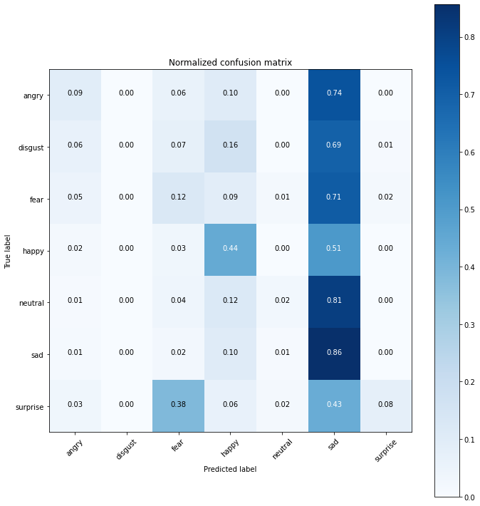

|  |  |  |  |  |
| --- | --- | --- | --- | --- |
| **support** | **f1-score** | **recal** | **precision** |  |
| 960 | 0.15 | 0.09 | 0.39 | **angry** |
| 111 | 0.00 | 0.00 | 0.00 | **disgust** |
| 1018 | 0.15 | 0.13 | 0.20 | **fear** |
| 1825 | 0.51 | 0.44 | 0.61 | **happy** |
| 1216 | 0.05 | 0.02 | 0.41 | **neutral** |
| 1139 | 0.33 | 0.86 | 0.21 | **sad** |
| 797 | 0.14 | 0.08 | 0.73 | **surprise** |
|  |  |  |  |  |
| 7066 | 0.30 |  |  | **accuracy** |
| 7066 | 0.19 | 0.23 | 0.36 | **macro avg** |
| 7066 | 0.25 | 0.30 | 0.43 | **weighted avg** |

**Epochs 3 (Vgg-16) - lr = 0.01:**

|  |  |  |  |
| --- | --- | --- | --- |
| **loss** | **accuracy** | **val_loss** | **val_accuracy** |
| 1.6341 | 0.3599 | 1.6272 | 0.3709 |

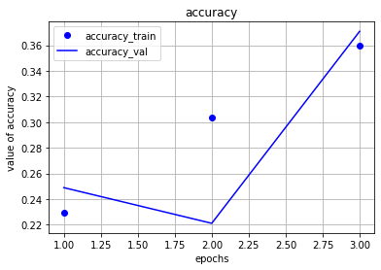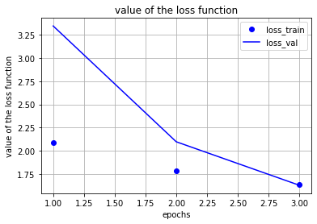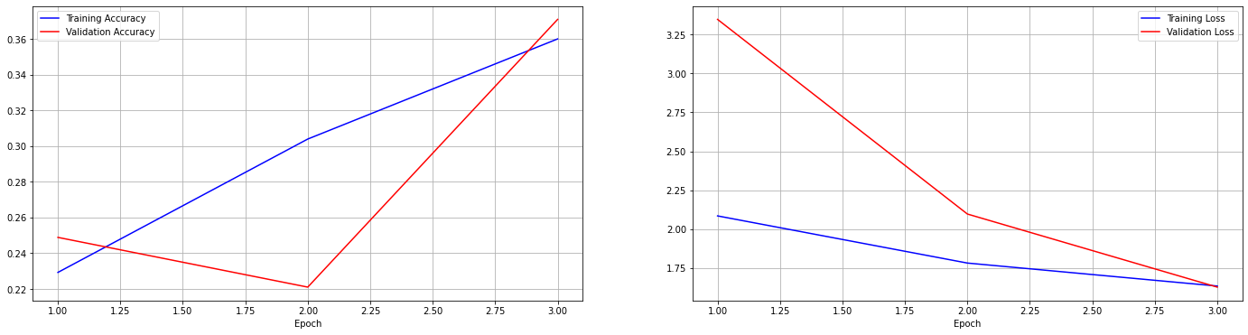

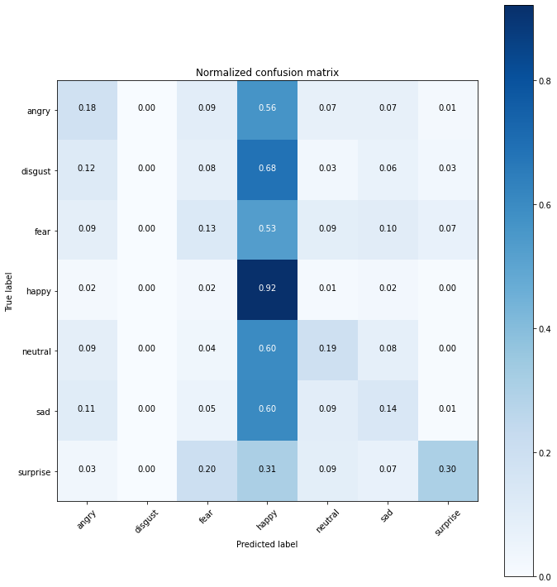

|  |  |  |  |  |
| --- | --- | --- | --- | --- |
| **support** | **f1-score** | **recal** | **Precision** |  |
| 960 | 0.23 | 0.18 | 0.32 | **angry** |
| 111 | 0.00 | 0.00 | 0.00 | **disgust** |
| 1018 | 0.17 | 0.13 | 0.24 | **fear** |
| 1825 | 0.53 | 0.92 | 0.37 | **happy** |
| 1216 | 0.26 | 0.19 | 0.39 | **neutral** |
| 1139 | 0.19 | 0.14 | 0.30 | **sad** |
| 797 | 0.42 | 0.30 | 0.69 | **surprise** |
|  |  |  |  |  |
| 7066 | 0.37 |  |  | **accuracy** |
| 7066 | 0.26 | 0.27 | 0.33 | **macro avg** |
| 7066 | 0.32 | 0.37 | 0.37 | **weighted avg** |

**Below you’ll see the charts tables for all the accuracy and loss for each epoch:**

***By Changing the Learning Rate***

|  |  |  |  |  |  |  |  |  |  |
| --- | --- | --- | --- | --- | --- | --- | --- | --- | --- |
|  | VGG -16 | | | | | CNN | | | |
|  |  | Validation | | Testing | | Validation | | Testing | |
| epochs |  | **Acc** | **Loss** | **Acc** | **Loss** | **Acc** | **Loss** | **Accuracy** | **Loss** |
| 3 |  | 0.2885 | 1.8112 | 0.2521 | 2.0215 | 0.2747 | 1.8179 | 0.2611 | 1.8565 |
| 5 |  | 0.3469 | 1.6724 | 0.2919 | 1.8827 | 0.3463 | 1.6766 | 0.2987 | 1.7789 |
| 10 |  | 0.4354 | 1.4951 | 0.3885 | 1.6344 | 0.4411 | 1.4396 | 0.3868 | 1.5713 |
| 25 |  | 0.5416 | 1.2104 | 0.5198 | 1.282 | 0.5229 | 1.2489 | 0.4433 | 1.4455 |
| 50 |  | 0.6074 | 1.0812 | 0.6095 | 1.0265 | 0.6048 | 1.0497 | 0.5927 | 1.0678 |

***For the different epochs that we applied***

|  |  |  |  |  |  |  |  |  |
| --- | --- | --- | --- | --- | --- | --- | --- | --- |
|  | **VGG - 16** | | | | **CNN** | | | |
|  | Validation | | Testing | | Validation | | Testing | |
| **LR** | Acc | Loss | Acc | Loss | Acc | Loss | Acc | Loss |
| **0.01** | 0.3709 | 1.6272 | 0.3599 | 1.6341 | 0.2962 | 1.7059 | 0.4113 | 1.5058 |
| **0.001** | 0.3736 | 1.612 | 0.4138 | 1.5589 | 0.4216 | 1.6721 | 0.4412 | 1.4503 |
| **0.0001** | 0.2885 | 1.8112 | 0.2521 | 2.0215 | 0.2747 | 1.8179 | 0.2611 | 1.8565 |

**#4. Conclusion**

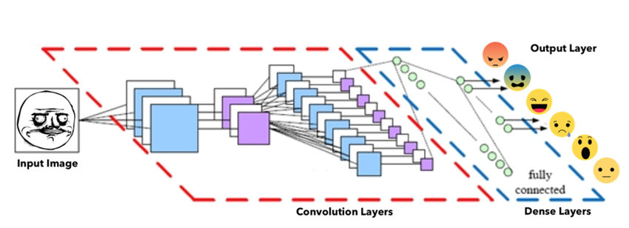

This image shows what happens in our project from start to finish,

At first, our project takes an image **(input image),**

then processes it, analyzes it and performs some operations on it to extract properties from images through the processes we mentioned and explained earlier **(process),**

And when we know the characteristics of the photo, we will know what is the condition of the person for whom the photo was taken (We will see then the condition of the person, whether he is angry or disgust or fear or happy or neutral or sad or surprise) **(output).**

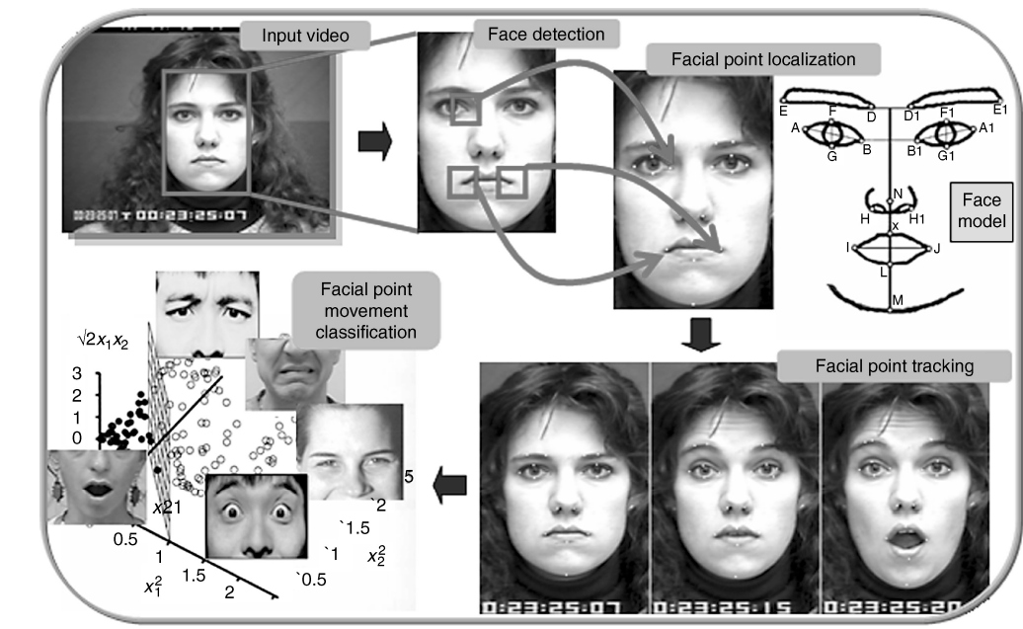

Figure(Facial Expression Recognition)